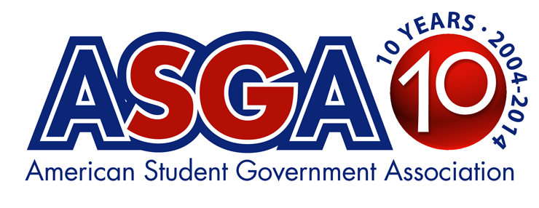
FOR IMMEDIATE RELEASE
CONTACT: W.H. “Butch” Oxendine, Jr, Executive Director
American Student Government Association
352-373-6907, ext. 103
Butch@asgaonline.com
(GAINESVILLE, FLORIDA-3/17/14)-- The American Student Government Association is 10 years old today, March 17, 2014. ASGA went “live” on March 17, 2004 with 100 founding member institutions and just added all 16 public institutions in the state of Alaska to reach 1,251 member institutions.
The national organization serves and supports collegiate Student Governments in all 50 states and in other countries including Egypt, the Bahamas, and England. ASGA produces 10 training conferences attended by thousands of student leaders and administrators, and provides private consulting and research for members.
In 2005, ASGA added its first conference in Philadelphia. The organization now produces 10 training conferences annually, and in October, will produce its 100th conference. “ASGA has produced more student government conferences than any other organization in higher education history,” says Butch Oxendine, executive director.
ASGA’s resources have grown and improved dramatically since its founding 10 years ago. ASGA has the world’s only searchable “SG Database” of student government information, contacts, and documents from every institution in the nation.
“Two years ago we added the “SG Tools” section which offers step-by-step guides and downloadable and streamable workshops and webinars to help our members with everything from improving voting to getting students to care about SG,” Oxendine says.
ASGA also conducts ground-breaking research for members on everything from student votes on boards of trustees to smoking policies on campus to the number of women and minorities serving in Student Government. Much of the research ASGA conducts has never been done on a national level before. “No one has ever gathered the depth of research ASGA has on SG voting trends, student votes on boards of trustees, student activity fees, Student Government compensation paid to elected officers,” Oxendine says.
“As a former advisor turned presentation team member, it’s great to see ASGA providing quality programs and member services to ensure enhanced self-governance by SG leaders across the country,” says Suzette Walden Cole. “Almost daily, I have the opportunity to engage with former conference attendees via social media, or email, to see the progress their making to enrich the quality of life for students on their respective campuses. It’s an honor to be connected to the work of the Association!”
“As a former student body president of what is now the largest public university in the nation at Arizona State University, I wish that the American Student Government Association (ASGA) had been around as a resource for our student government when I was in office in 1997-98,” says Andy Ortiz, JD, MPA, President & CEO, Ortiz Leadership Systems, LLC. “However, I have been proud to be a speaker for ASGA since its founding 10 years ago. ASGA has become the ‘gold standard’ for student government conferences and leadership resources.”
“I truly enjoy being a part of an Association that is committed to being a good partner to students, advisors, and institutions,” says Sarah E. Schoper, Ph.D., Assistant Professor at Western Illinois University. “The resources that ASGA provides are practical and delivered quite often in a fun and engaging manner. Perhaps most important, however, is that ASGA's resources are useful and current.”
“I am so proud of ASGA and the commitment that they have shown to college student leaders around the country,” says Christopher C Irving, Executive Director & CEO, The Ceceilyn Miller Institute for Leadership and Diversity in America. Becoming a part of their speaker team has been the best thing to happen to me personally and professionally.”
Oxendine says ASGA plans to offer new resources, including “How to Get What You Want” and “How to Get Publicity” for members in the coming months. ASGA also is planning a huge-scale upgrade of the software that runs the entire ASGA web site, making searches more intuitive and faster. “We’ve had a very exciting and rewarding first 10 years of serving collegiate student governments,” Oxendine says. “All of us are excited about what the next 10 years will bring!”

--30--

